ASSIGNMENT – 9

Consider the following relations and Draw the ER, EER Diagram, Relational Model.

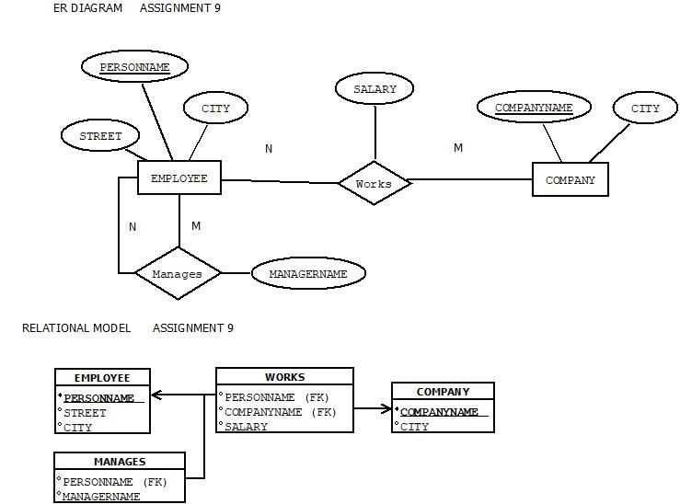

ASSUMPTIONS:

1. The relationship between **Employee and Company** through the works table is **many-to-one**:  
   Many employees can work for one company, but each employee works for only one company.
2. The relationship between **Company and Employee** (again via works) is **one-to-many**:  
   One company can have many employees working for it.
3. The relationship in the **manages** table (between employees and their managers) is a **one-to-many recursive relationship**:  
   One manager can manage many employees, but each employee has only one manager.

2) CREATE TABLE EMPLOYEES(

PERSONNAME VARCHAR2(15) PRIMARY KEY,

STREET VARCHAR2(15),

CITY VARCHAR2(15)

);

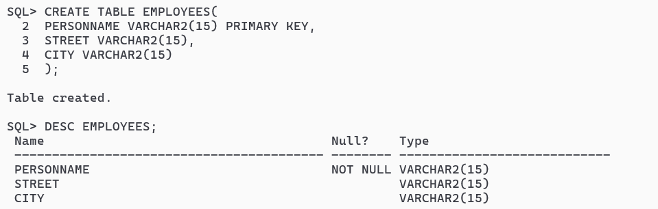

CREATE TABLE COMPANYS(

COMPANYNAME VARCHAR2(10) PRIMARY KEY,

CITY VARCHAR2(15)

);

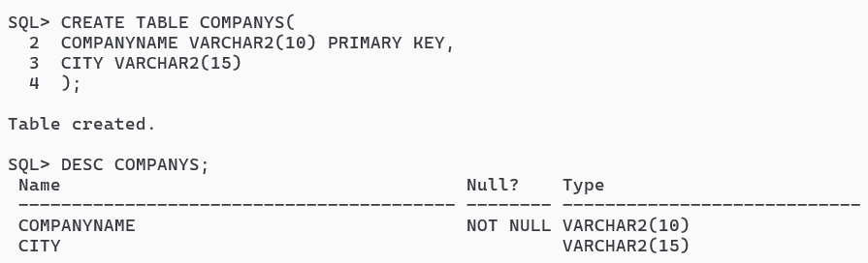

CREATE TABLE WORK(

PERSONNAME VARCHAR2(15),

COMPANYNAME VARCHAR2(10),

SALARY NUMBER(10,2),

FOREIGN KEY(COMPANYNAME) REFERENCES COMPANYS(COMPANYNAME) ON DELETE CASCADE,

FOREIGN KEY(PERSONNAME) REFERENCES EMPLOYEES(PERSONNAME) ON DELETE CASCADE

);

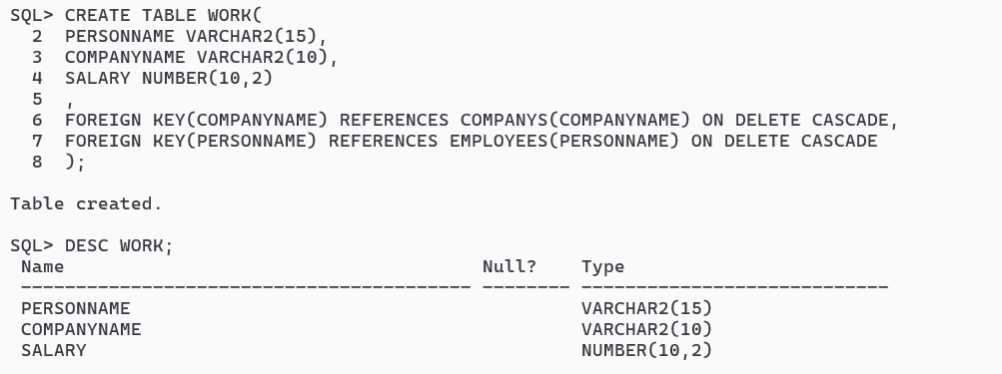

CREATE TABLE MANAGE(

PERSONNAME VARCHAR2(15),

MANAGERNAME VARCHAR2(15),

PRIMARY KEY (PERSONNAME),

FOREIGN KEY (PERSONNAME) REFERENCES EMPLOYEES(PERSONNAME),

FOREIGN KEY (MANAGERNAME) REFERENCES EMPLOYEES(PERSONNAME)

);

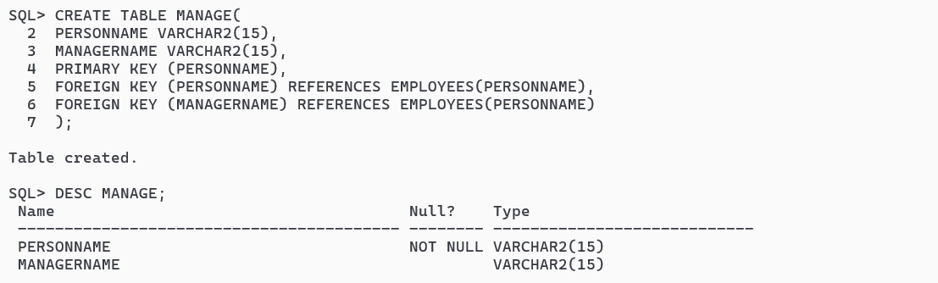

INSERT ALL

INTO EMPLOYEES VALUES('JOHN SMITH','MARKET AVENEU','SILCHAR')

INTO EMPLOYEES VALUES('NORA DAVIS','PARK STREET','KOLKATA')

INTO EMPLOYEES VALUES('OHM LUIS','RIVER ROAD','BANARAS')

INTO EMPLOYEES VALUES('RITA SEN','PARK LANE','SHIMLA')

INTO EMPLOYEES VALUES('SAGOR THAKUR','MARINE DRIVE','MUMBAI')

SELECT * FROM DUAL;

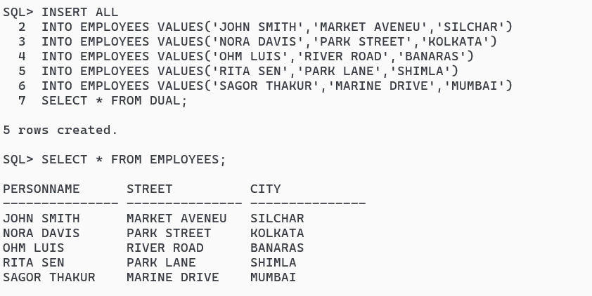

INSERT INTO COMPANYS VALUES('AXIS','MUMBAI');

INSERT INTO COMPANYS VALUES('CANARA','BANARAS');

INSERT INTO COMPANYS VALUES('SBI','SHIMLA');

INSERT INTO COMPANYS VALUES('KOTAK','SILCHAR');

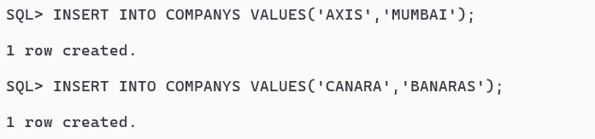

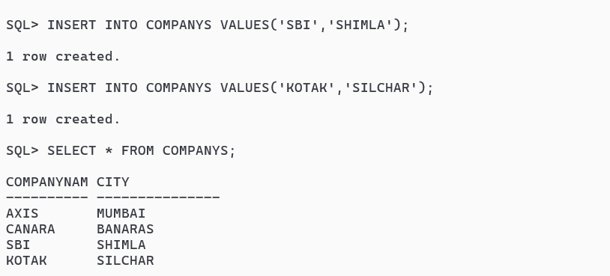

INSERT INTO WORK VALUES ('NORA DAVIS', 'AXIS', 40000.00);

INSERT INTO WORK VALUES ('JOHN SMITH', 'AXIS', 32000.00);

INSERT INTO WORK VALUES ('OHM LUIS', 'SBI', 28000.00);

INSERT INTO WORK VALUES ('RITA SEN', 'KOTAK', 37000.00);

INSERT INTO WORK VALUES ('SAGOR THAKUR', 'AXIS', 45000.00);

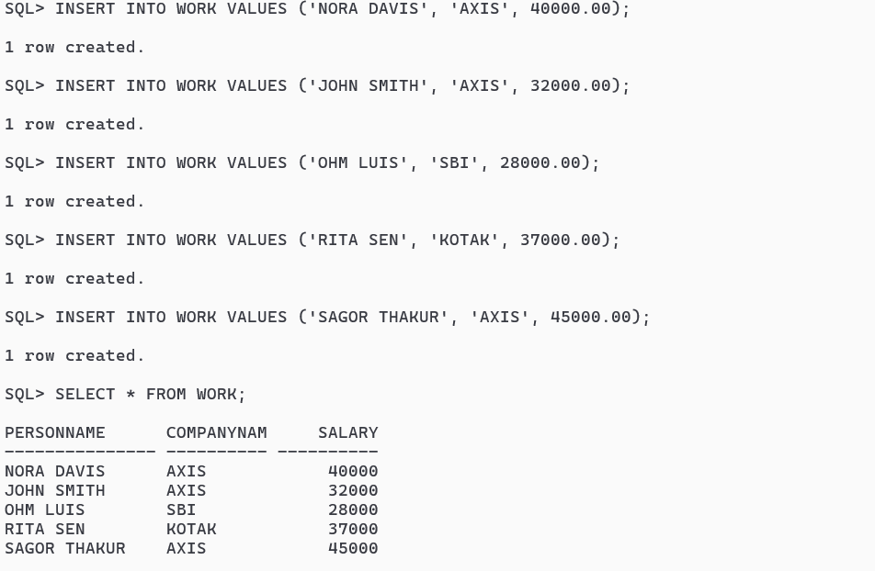

INSERT INTO MANAGE VALUES ('NORA DAVIS', 'JOHN SMITH');

INSERT INTO MANAGE VALUES ('RITA SEN', 'OHM LUIS');

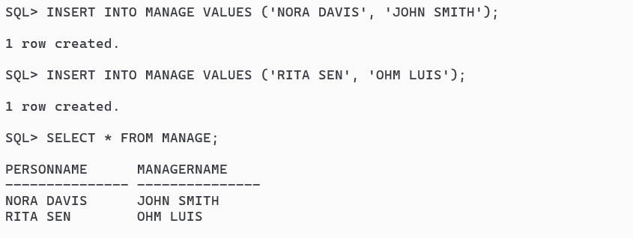

Q) Consider the following relations write the SQL statement for the following queries:  
Create the tables and insert 5 sets of records into each.  
• employee (personname, street, city)  
• works (personname, companyname, salary)  
• company (companyname, city)  
• manages (personname, managername)

a) Find the names of all employees who work for Axis Bank.

SELECT PERSONNAME FROM WORK WHERE COMPANYNAME='AXIS';

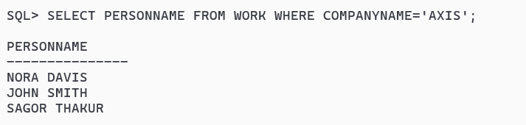

b) Find the names and cities of residence of all employees who work for Axis Bank.

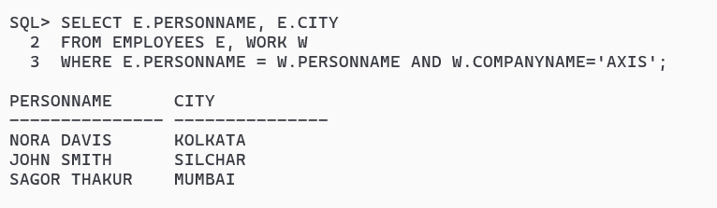

c) Find the names, street addresses, and cities of residence of all employees who work for Axis Bank and earn more than Rs.30000 per annum.

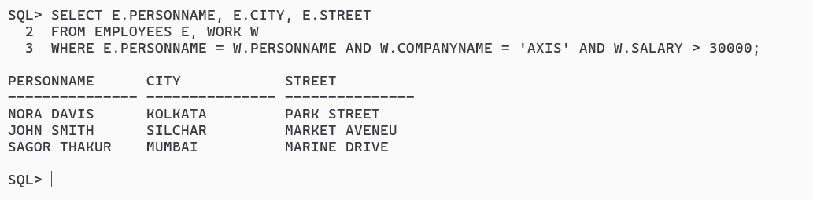

d) Find all employees who live in the same city as the company for which they work is located.

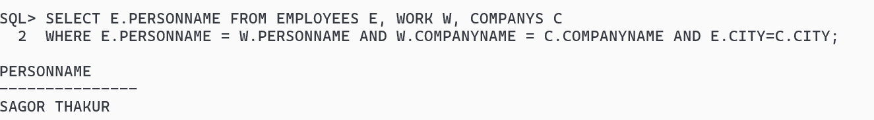

e) Find all employees who live in the same city and on the same street as their managers.

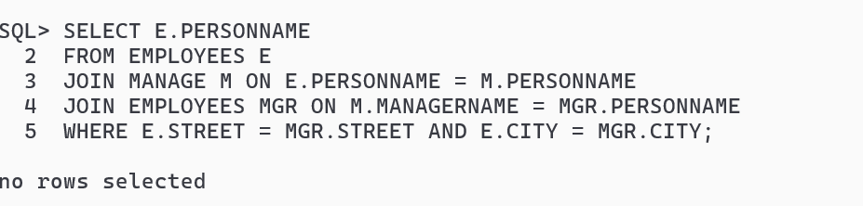

f) Find all employees in the database who do not work for Axis Bank.

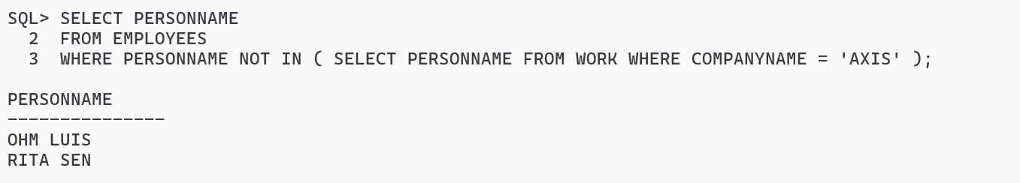

g) Find all employees who earn more than every employee of Axis Bank.

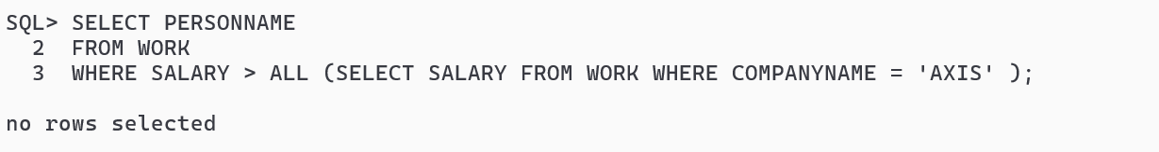

h) Assume that the companies may be located in several cities. Find all companies located in every city in which Axis Bank is located.

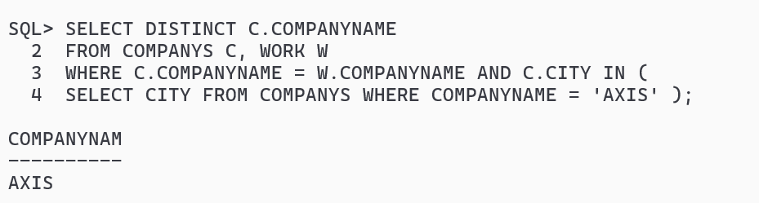

i)Find all employees who earn more than the average salary of all employees of their company.

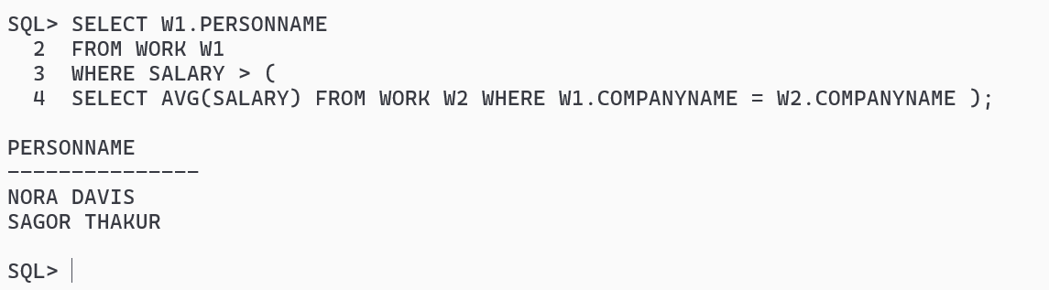

j) Find the company that has the most employees.

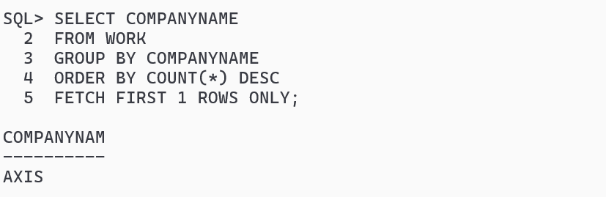

k) Find the company that has the smallest payroll.

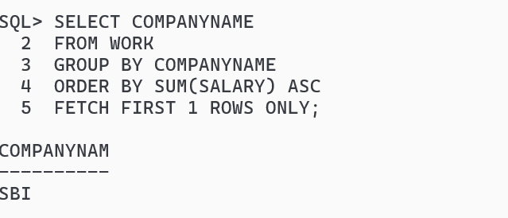

l) Find those companies whose employees earn a higher salary, on average, than the average salary at Axis Bank.

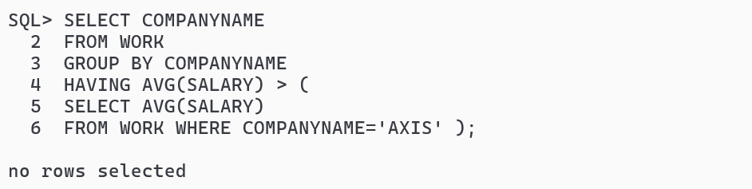

m) Modify the database so that ABC now lives in Kolkata.

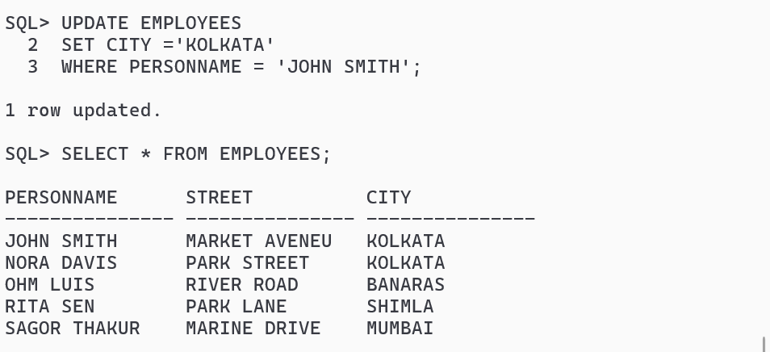n) Give all employees of Axis Bank a 10 percent raise.

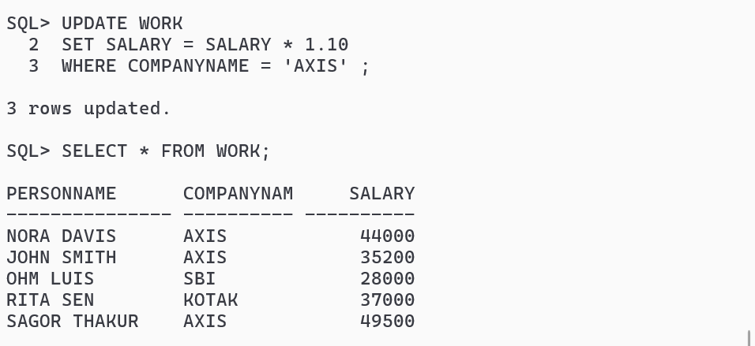

o) Give all managers in the database a 10 percent raise.

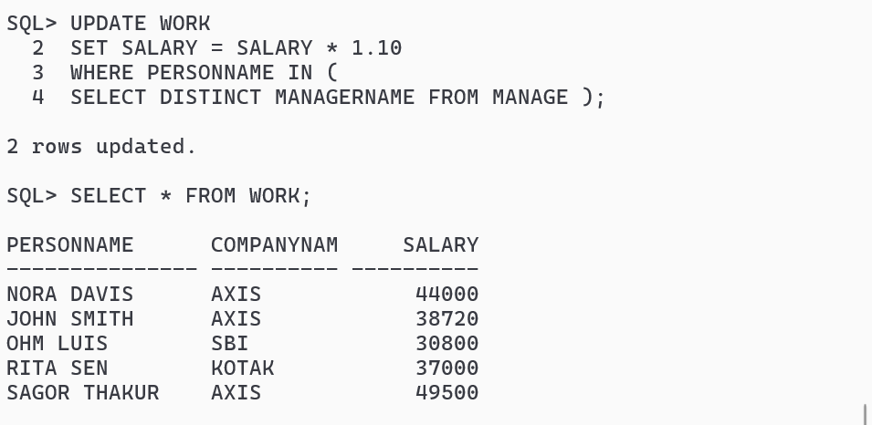

P) Give all managers in the database a 10 percent raise, unless the salary would be greater than Rs.300000.In such cases, give only a 3 percent raise.

